Research document of JavaScript framework

Written by Mohammed Alharbi

Contents
Contents 1
Research part 1
Introduction 1
What is a JavaScript framework? 2
History of most popular frameworks 2
Popularity of each framework 2
Job demand and chances of employability 4
Learning curve for each framework 5
Key Characteristics for Vue framework 6
Key Characteristics for React framework 6
Design part 7
My Personal Opinion and choice 7
Important Decisions 7
Proof of using SOLID principles 7
UML 8
ER 9
References 9

Research part
The following sections in the document belong to the research of frameworks.

Introduction

In this research document I will be comparing frameworks in order to clarify which option is probably the framework that suits project needs. This document aim is to find out which framework suits the need to develop the product for the given context. Thus, that document is going to provide some key characteristics regarding JavaScript frameworks and other relevant information about it. This document will be using available information via sources such as websites.

What is a JavaScript framework?

A JavaScript framework is basically a library that is used to develop front-end that interact with the end-user. There are different JavaScript frameworks, but the most famous ones are Angular, Vue and React.

History of most popular frameworks

React was developed in 2013 by Facebook and famous contributor Uber. Angular is the oldest, it was developed in 2010 by Google famous contributors Wix.com. Vue is the youngest among these frameworks. It was developed in 2014 by an ex-google employee (Evan you), famous contributors Alibaba (which also considered to be the youngest among them).

(Daityari, 2021)

Popularity of each framework

The following data visualization aims to clarify the popularity using number of downloads for the past 2 years and the stars that each framework has received:

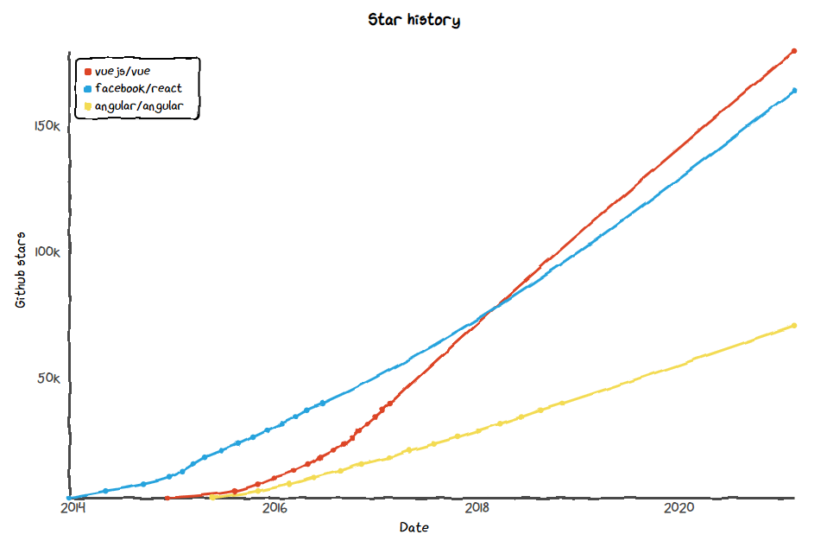
Figure 1
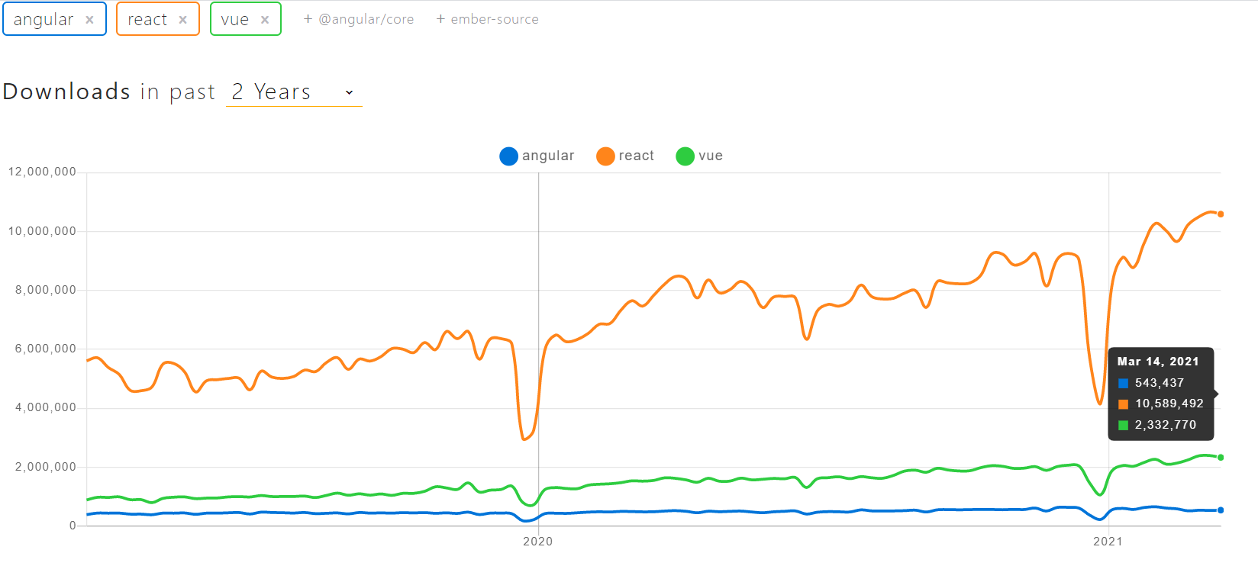
Figure 2
According to figure 1 it is obvious that the most liked framework among developers is Vue. One of the reasons that allowed Vue to be the most stared framework in git is that the framework itself is very intuitive which makes it easier to pick up and thus the learning curve of Vue framework is not steep at all. Whereas figure 2 represents the number of downloads for each popular framework and Vue is apparently is setting on the second most downloaded framework for the past 2 years while React is on the top.

Job demand and chances of employability

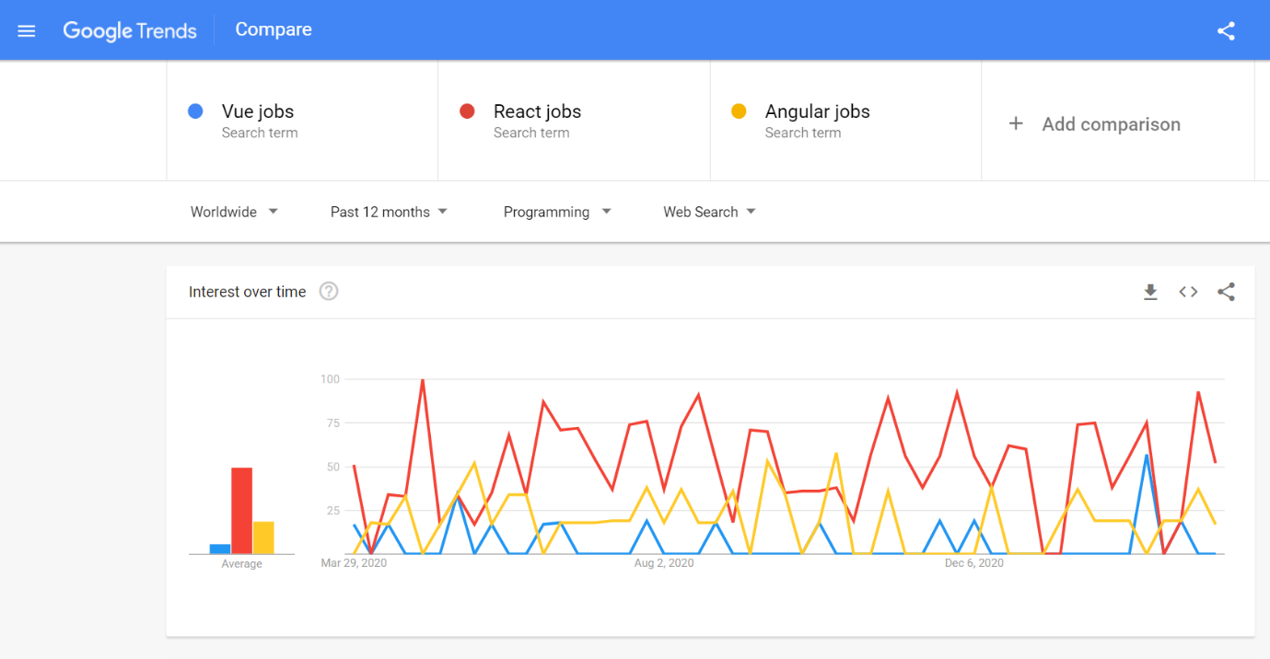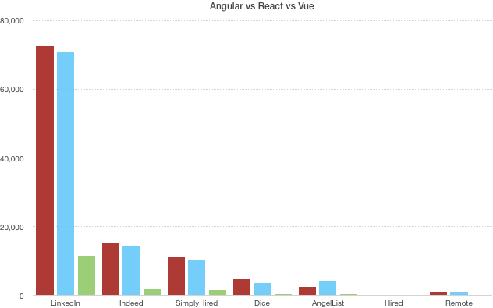

According to the statistics shown in the previous 2 data visualizations Vue framework job demand is extremely low. There are a few reasons that might cause that first being the contributors as mentioned in the brief history section Vue is the newest framework out there and does not have as big contributors such as Google or Facebook. Second being Vue is an open-source framework and it does lack some complex elements. For instance, a date time picker, and for such situations it requires adding it manually or by a third-party library. While the job demanding is dominated by React on top followed by Angular. Thus, odds are learning react might be a bit tougher than Vue but has a better potential to get a job whereas, Vue easier to pick up and way harder to find a job that utilizes Vue framework.

( Neagoie, 2018)
(Daityari, 2021)

Learning curve for each framework

Angular framework has a steep learning curve and go back to the purpose of why Angular was developed in first place. It requires you to be familiar with some concepts such as TS (TypedScript) and MVC (Model-View-Controller).

React framework does not have a steep learning curve as Angular but a solid one. Some functions may require a third-party to be developed and thus it is not as advanced as Angular.

Vue framework has the easiest learning curve among the 3 and it is highly customizable. It also provides a dashboard to control in browser to facilitate the usage of the framework. However, a flex and simple framework like Vue allows poor designed code to be hard to debug.

(Daityari, 2021)

Table of comparisons

 | Angular | React | Vue
Learning Curve | Considered harder | Has an easier learning curve than Angular. It uses Ajax that looks like HTML to make things a bit more intuitive. | Considered to be the easiest learning curve
Job Chances | About 50% of the front-end jobs require Angular | About 48% of the front-end jobs require React | Very low percentage of job chances
Popularity | Well-known, made by Google, was the oldest. | Very famous, made by Facebook and was developed 3 years after Angular came out. | Very famous but does not have a big company to support it and its technology liked by many developers.

REF: https://zerotomastery.io/blog/tech-trends-showdown-react-vs-angular-vs-vue/

Key Characteristics for Vue framework

Vue framework is probably the most popular framework as it was clarified previously. However, it just does not have that big company behind it unlike Angular with Google or React with Facebook.
It is a complete framework to build components but smaller than Angular or has less features. It has less packages than Angular for example, no form validation. Vue framework also utilizes native WEB API (uses HTML CSS). Primarily used for web applications but it can also be utilized to develop mobile applications with Ionic or NativeScript.

Ref link: https://www.youtube.com/watch?v=SWZ_4YBFBhs

Key Characteristics for React framework

React framework has that big company behind it that being Facebook which is one of the main reasons why react has such a huge job demand and the chances for to get hired is high. Thus, working hard to learn would pay off in the long run. It has a decent learning curve, and it allows the developer to use AJAX that looks like HTML to make it a bit more intuitive.

Design part
The following part regards the design, choices and the important decisions.

My Personal Opinion and choice

I researched for the 3 famous frameworks and I found out that Angular would be the most difficult framework but would enable me to have better job chances if learnt properly so that is considered better in the long run. The same idea applies to React, but the difficulty is a bit lower in comparison with Angular. Vue is probably the most liked and considered easiest however it doesn’t have that much support on it so learning that would not be the best option in the long run.

Considering the previous factors, the option I considered were Vue and React. As for my group framework we all decided that we would be working with React as our JavaScript Framework because of the benefits we gain in the long run. Therefore, I decided to go with that for the same reason in addition to the fact that working in 2 different JavaScript frameworks would be a bit hard.

Important Decisions

First important decision I made is using Spring boots. It is a must have framework in my project. The main reason for that is because I need to make an API and the framework enables me to do that part. Second important decision is that the project I am developing should be maintainable, extendable and secure. Therefore, I decided to use Object-Oriented principles to enable the probability of maintainability and extensibility. Making sure to use the appropriate access modifiers to the variables would enable the security part in the application.

Proof of using SOLID principles

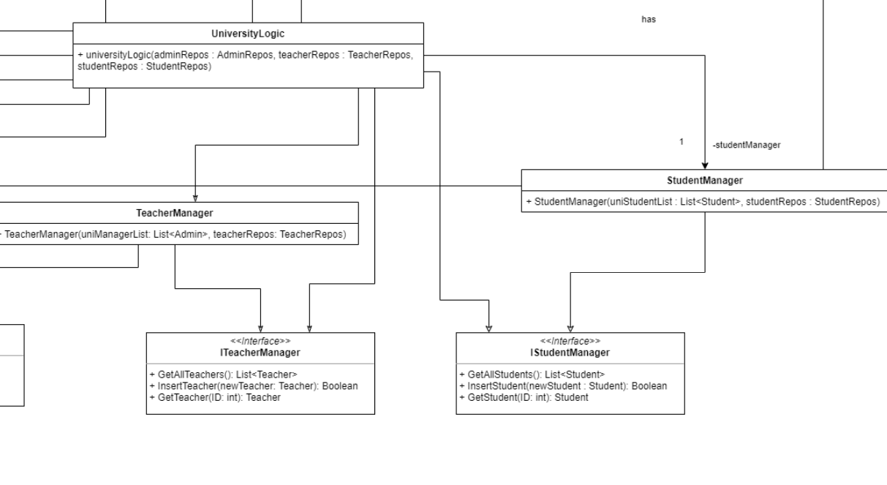
That is a snippet of UML for the second sprint and there I manage the functions that regards to each module specifically in the manager of that module which in this case follows the “Single Responsibility principle”.

UML



ER



References

The information gathered using the following links:

https://vuejs.org/v2/guide/comparison.html

https://www.codeinwp.com/blog/angular-vs-vue-vs-react/

https://star-history.t9t.io/#facebook/react&vuejs/vue&angular/angular

https://zerotomastery.io/blog/tech-trends-showdown-react-vs-angular-vs-vue/

https://www.npmtrends.com/angular-vs-react-vs-vue

https://trends.google.com/trends/explore?cat=31&q=Vue%20jobs,React%20jobs,Angular%20jobs

https://www.youtube.com/watch?v=wURF45fj2fA

